Dear Student,

Congratulations! You have been nominated by one of your teachers as an excellent candidate to participate in the 2018 International Tour. This invitation to travel is for both you and your parents.

Imagine yourself…
- Engaging with a world beyond their classroom and local community
- Stepping outside of their comfort zone and experiencing new foods, cultures and people
- Receiving an experience that will help him/her stand out on college or job applications
- Learning to navigate new situations with confidence and maturity, and appreciating the difference of others
- Experiencing a life changing journey

Where are we going?
In the summer of 2018, we will be traveling to [COUNTRY/COUNTRIES]. We will be visiting the cities of [major cities]. Some of the highlights include [HIGHLIGHTS].

What are next steps?
I will be hosting an enrollment meeting on [DATE] at [TIME] AT [LOCATION] to provide more details about this opportunity, answer any questions you may have, and give you everything that you need to get signed up. Please send me an email or return the RSVP slip below by [DATE] to ensure I can accommodate everyone in our meeting space.

I hope that you are excited to learn more about this incredible opportunity! This trip is open to all students at [NAME OF SCHOOL], so there is limited space available on the tour and I do expect the spots to fill quickly.

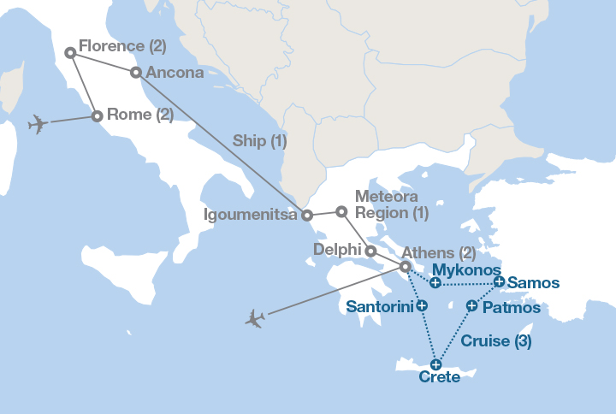
Trip Highlights:
The Coliseum
The Duomo
Delphi
Temple of Apollo
The Acropolis
The Parthenon
Greek Island Cruise

Warm regards,

Jessica Taylor
Jessica.taylor@wylieisd.net

-----------------------------------------------Please fill out and return to Jessica Taylor-------------------------------------------
___ Yes, I plan to attend the informational meeting on [DATE], at [LOCATION]
___ I’m unable to attend this meeting but am interested in participating. Please contact me with more information.
___ I am not interested at this time.
Student Name: _______________________________________________________________
Parent/Guardian Name: ________________________________________________________
Parent/Guardian Phone Number: _________________________________________________
Parent/Guardian Email: _________________________________________________________

