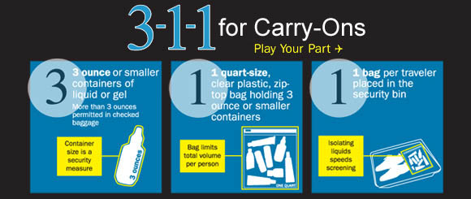

Make Your Trip Better Using 3-1-1
TSA and our security partners conducted extensive explosives testing since August 10, 2006 and determined that liquids, aerosols and gels, in limited quantities, are safe to bring aboard an aircraft. The one bag limit per traveler limits the total amount each traveler can bring. Consolidating the bottles into one bag and X-raying them separately from the carry-on bag enables security officers to quickly clear the items.
3-1-1 for carry-ons = 3.4 ounce (100ml) bottle or less (by volume) ; 1 quart-sized, clear, plastic, zip-top bag; 1 bag per passenger placed in screening bin. One-quart bag per person limits the total liquid volume each traveler can bring. 3.4 ounce (100ml) container size is a security measure.
Be prepared. Each time TSA searches a carry-on it slows down the line. Practicing 3-1-1 will ensure a faster and easier checkpoint experience.
3-1-1 is for short trips. If in doubt, put your liquids in checked luggage.
Declare larger liquids. Medications, baby formula and food, and breast milk are allowed in reasonable quantities exceeding three ounces and are not required to be in the zip-top bag. Declare these items for inspection at the checkpoint.

