France, Germany and Switzerland – Summer 2013

March 25, 2013: Travel Safety
(only 89 days until we depart!)

- “Oh, the Places We’ll Go!” (Paris)
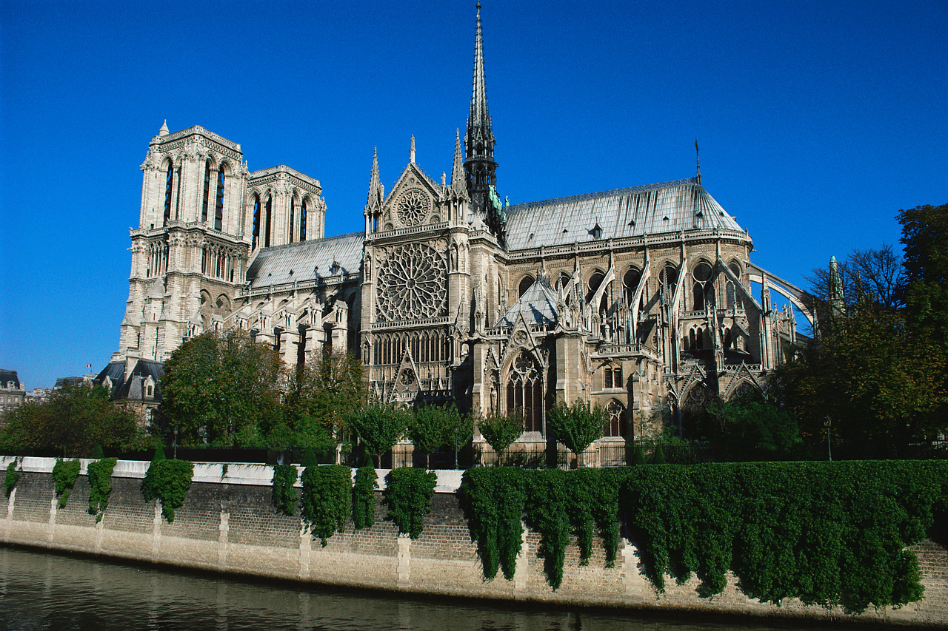

- General Business
  - Date of tour: June 22-30, 2013

  - Passports! Please bring so that I can make copies

  - Tips - $90.00 (covers all tipping, money due May 6th.)
You are receiving a tip envelope tonight. Please return it
at the next meeting with $90 cash or a check made out to
Jessica Taylor. Ms. Taylor will combine and convert the
money, and tip for the whole group.

  - Sign up for text reminders:
    - Text @tripsu to 262-287-9542

  - I still need forms turned in! Pick up an extra copy
if you need it.

  - Travel to the airport on June 22nd. We need to decide
how we are going to get to the airport? Two options:
1. Hire a shuttle: $10/each
2. Car pool from Wylie East (need parent volunteers)
Next meeting: May 6th
~Packing~

Bring to the next meeting:
- Tip envelope w/tip money
- Passport

- Travel Safety
  - Rules of the Road
  - Travel Safety Do’s and Don’ts

- T-Shirts
  - The t-shirts will cost $12.00 each. I already have your shirt sizes. You can include payment with your tips, if you would like. Make checks out to Jessica Taylor
  - We need to vote for a design tonight.

- Roommates
We need to make our tentative roommate list tonight. Ms. Taylor will give instructions on how to do this. See list on back of this sheet.

- Thinking Ahead

  - Money
    - Suggested $50 per day for spending money (Around $400-$450 total)
    - Please have some cash on hand upon landing in Greece, I highly recommend getting some Euro before you leave.

  - Converter/Adapter
France, Germany and Switzerland – Summer 2013
Tour Members

Girls:
Catherine Boyoma
We need combinations of:
4 girls/boys to a room
3 girls/boys to a room
2 girls/boys to a room

*There is an uneven number of both boys and girls, so there will be some students who will have to overflow into another room.
Caitlin Gipson
Whitnee Gray
McKenna Tilton
Michaela Watson

Boys:
Niko Gilmore
William Jackson
Justin Johnson
Stephen Lorenz
Jimmy Maslowski
Chris Paul
Flint Willingham

