France, Germany and Switzerland – Summer 2013

January 14, 2013: What to Expect…Life on Tour
(only 154 days until we depart!)

- Group member introductions
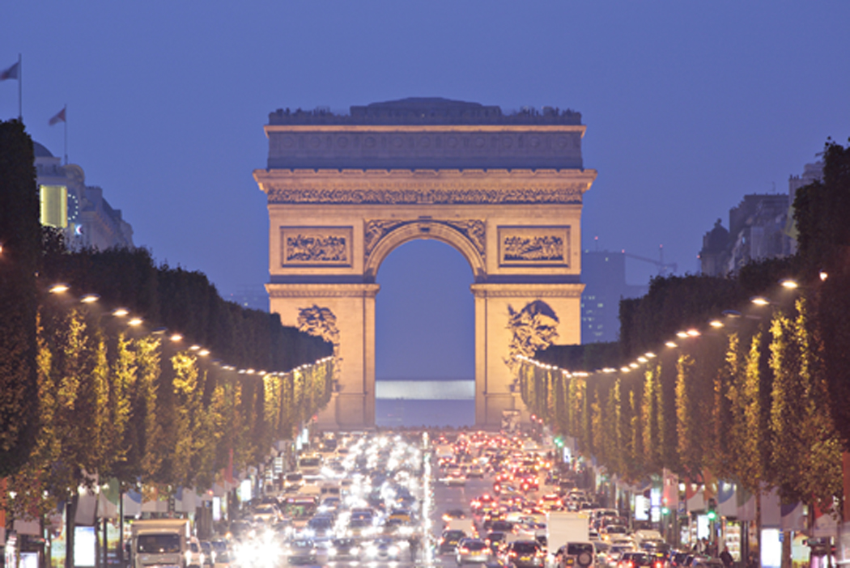

- Fundraising

- “Oh, the Places We’ll Go!” – (Paris)

- General Business
  - Requested Date of tour: June 17-25, 2013

  - Bring Passport to next meeting

  - Tips - $90.00 (covers all tipping, money due on May 6th.)

  - Design our group shirt! Use www.bluecotton.com and e-mail your design to jessica.taylor@wylieisd.net from the bluecotton website.

  - Sign up for text reminders:
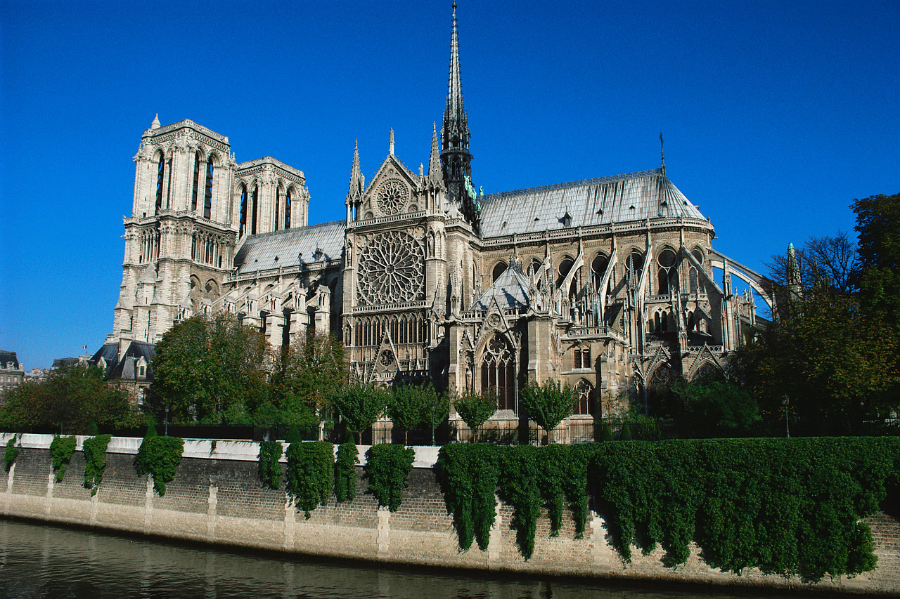
    - Text @tripsu to 262-287-9542

  - You will find the following in your folder:
    - Bio Sheet (handout) need to return
    - Ms. T’s non-negotiables (handout)
    - Phone Tree Form (handout) need to return
    - Medical Form (handout) need to return
    - Behavior Agreement (handout) need to return

- What to expect on tour
  - Itinerary (handout)
  - Daily schedule
  - Things to be prepared for

- Optional Excursions
  - Versailles ($98)
  - Mt. Pilatus ($85)

- Thinking Ahead
  - Roommates. We will make our roommate list at the next meeting. Please be thinking about who you would like to room with. *See a list of travelers on back of this page.
  - Money
    - Prepaid Debit Card (from Travelex…they call this the “cashport)
    - Suggested $50 per day for spending money (Around $400 total)
    - Please have some cash on hand upon landing in Greece, I recommend getting some Euro before you leave.
  - Converter/Adapter
Next meeting: March 25th, 2013
Bring to the next meeting:
- Completed phone tree form
- Completed Behavior Agreement
- Completed Medical Agreement
- Passport – to make copies

France, Germany and Switzerland – Summer 2013

Tour Members

Girls:
Whitnee Gray
McKenna Tilton
Michaela Watson

Boys:
Niko Gilmore
William Jackson
Justin Johnson
Stephen Lornez
Jimmy Maslowski
Chris Paul
Flint Willingham

